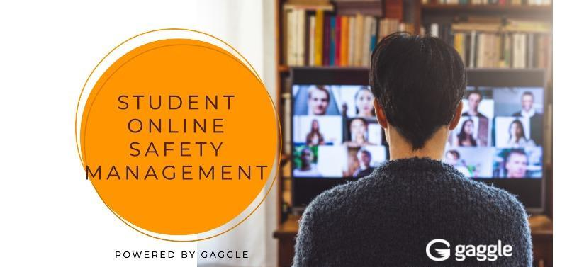

What is the Gaggle Safety Management System?
Gaggle is a safety management tool that helps support student safety and well-being using Google Email, Google Drive, and Canvas Learning Management System (LMS). It also helps ensure that students are safely and correctly using school-provided digital tools in accordance with the policies and guidelines defined by the current Parent Student Handbook and Acceptable Use Policies.

How does Gaggle work?
Gaggle uses a combination of artificial intelligence and trained safety experts to review students’ use of online tools within Google and Canvas and provide real-time analysis of potentially concerning behavior or content. Gaggle’s technology scans students’ CMS-issued accounts for harmful content. It alerts school officials if students show signs of self-harm, depression, thoughts of suicide, substance abuse, cyberbullying, credible threats of violence against others, or other harmful situations.

Why is such monitoring necessary?
When it comes to school safety, students, teachers, administrators, and parents must work together as part of a comprehensive district-wide security plan.

CMS is committed to educating and supporting students’ social-emotional wellness and healthy ways to cope with intense emotions and handle the ups and downs of everyday life. In addition to the proactive and professional services delivered by teaching staff and counselors, resources such as Gaggle are necessary to identify students in acute distress and in need of emergency intervention to address suicidal ideation or thoughts to harm others. Identifying students during a crisis can make all the difference in saving lives and supporting students with the emergency resources needed.

What is monitored by Gaggle?
Any cloud-based Google communications and documents are monitored, including school email, chat, and documents created, sent, or received by the student using their district-issued Google account. Additionally, Gaggle will monitor messages and content within the Canvas LMS.

What is not monitored by Gaggle?
Gaggle does not monitor devices or any personal accounts, including but not limited to internet usage and web browsing, cellular phone calls, text messages, social media posts, and personal email accounts. Teacher and staff CMS accounts are not monitored.

My student occasionally works on schoolwork using their home computer. Will my home computer be monitored?
CMS will NEVER monitor your home computer or cell phone. However, anytime a student is logged into their CMS account, the district is responsible for what occurs in that digital environment, regardless of the location it is being accessed. Therefore, all content from a student’s CMS account will be reviewed to ensure students are practicing good digital citizenship.

Does Gaggle censor words, student work, and searches?
No. Gaggle utilizes artificial intelligence (AI) and machine learning (ML) to identify potentially concerning language that is being used to target another student in an inappropriate, harassing, or bullying manner. If these words are being used in student narrative writing, research, or some other educationally appropriate way, then no further investigation is conducted, nor is any action taken.

Does Gaggle Safety Management work with social networks like Facebook or Snapchat?
Gaggle Safety Management works exclusively with communication and collaboration tools the district has provided to our students. We do not monitor a student’s personal social media accounts.

How is a web filter different from Gaggle?
A web filter is software designed to restrict or control the online content that a user is allowed to access. The intention is to keep someone or something out of an unhealthy area. Gaggle’s goal is to provide early warning detection of harmful situations and to help our District decide where to direct resources to address digital citizenship, bullying prevention, and mental health issues.

What is done with the data collected?
Data collected by Gaggle focuses on CMS district-issued email, chat, files, and documents and does not collect sensitive information. No data is shared with third parties, and any personally identifiable information collected is available only to the designated school district personnel to help intervene and provide student assistance and ensure student safety. Gaggle’s data privacy policy is available for review on their website: Gaggle Student & Staff Data Privacy Notice.

How are we ensuring compliance with student privacy laws?
Gaggle is both Family Educational Rights and Privacy Act (FERPA) and Children’s Online Privacy Protection Act (COPPA) compliant. FERPA is a federal law focusing on the protection of the privacy of personally identifiable information in students' education records. COPPA is a federal law designed to protect the privacy of children under 13 years old. Both laws protect a student’s privacy in terms of educational records, including information such as a student's name or identification number, which can be used to distinguish or trace an individual's identity, either directly or indirectly, through linkages with other information.

Does Gaggle comply with the Family Educational Rights and Privacy Act (FERPA) and state-specific guidelines like Student Online Personal Information Protection Act (SOPIPA) in California concerning student data privacy?
Access to certain student information remains the legal responsibility of the applicable school or district, which is required to comply with FERPA and its applicable regulations. One of FERPA’s core tenets is the protection of the privacy of personally identifiable information (PII) in students’ education records. It is Gaggle’s policy to comply with all applicable state and federal laws, including FERPA.

Gaggle only uses PII from students’ education records to enable the use of Gaggle solutions. Unless a school official expressly instructs otherwise, we will not share or reuse PII from education records for any other purpose. For more details about Gaggle and FERPA, consult the Gaggle Student & Staff Data Privacy Notice.

